**ALGORITMA DAN STRUKTUR DATA**

**MODUL 6**

**PENGURUTAN LANJUTAN**



**Disusun oleh:**

Muhammad Ferizal Fadhli

L200210119

D

**TEKNIK INFORMATIKA**

**FAKULTAS KOMUNIKASI DAN INFORMATIKA**

**UNIVERSITAS MUHAMMADIYAH SURAKARTA**

**2022/2023**

Soal-soal Mahasiswa

1. Ubahlah kode mergeSort dan quickSort di atas agar bisa mengurutkan list yang berisi object-object mhsTIF yang sudah kamu buat di Modul 2. Uji programmu secukupnya.

Berikut kode program :

class MhsTIF(object):

    """Class MhsTIF yang dibangun dari class Mahasiswa"""

    def __init__(self,nama,NIM,kota,us):

        """Metode inisialisasi ini menutupimetode inisiasi di class Manusia."""

        self.**nama**=nama

        self.**NIM**=NIM

        self.**kotaTinggal**=kota

        self.**uangsaku**=us

c0 = MhsTIF('Ika', 10, 'sukoharjo', 240000)

c1 = MhsTIF('Budi', 51, 'sragen', 230000)

c2 = MhsTIF('Ahmad', 2, 'surakarta', 250000)

c3 = MhsTIF('Chandra', 18, 'surakarta', 235000)

c4 = MhsTIF('Eka', 4, 'boyolali', 240000)

c5 = MhsTIF('Fandi', 31, 'salatiga', 250000)

c6 = MhsTIF('Deni', 13, 'klaten', 245000)

c7 = MhsTIF('Galuh', 5, 'wonogiri', 245000)

c8 = MhsTIF('Janto', 23, 'klaten', 245000)

c9 = MhsTIF('Hasan', 64, 'karanganyar', 270000)

c10 = MhsTIF('Khalid', 29, 'purwadadi', 265000)

Daftar = [c0.**NIM**,c1.**NIM**,c2.**NIM**,c3.**NIM**,c4.**NIM**,c5.**NIM**,c6.**NIM**,c7.**NIM**,c8.**NIM**,c9.**NIM**,c10.**NIM**]

def mergeSort(nlist):

    print("Membelah ",nlist)

    if len(nlist)>1:

        mid = len(nlist)//2

        lefthalf = nlist[:mid]

        righthalf = nlist[mid:]

        mergeSort(lefthalf)

        mergeSort(righthalf)

        i=j=k=0

        while i < len(lefthalf) and j < len(righthalf):

            if lefthalf[i] < righthalf[j]:

                nlist[k]=lefthalf[i]

                i=i+1

            else:

                nlist[k]=righthalf[j]

                j=j+1

            k=k+1

        while i < len(lefthalf):

            nlist[k]=lefthalf[i]

            i=i+1

            k=k+1

        while j < len(righthalf):

            nlist[k]=righthalf[j]

            j=j+1

            k=k+1

    print("Menggabungkan ",nlist)

nlist = Daftar

print("Hasil dari MergeSort")

mergeSort(nlist)

print(nlist)

def quickSort(data_list):

   quickSortHlp(data_list,0,len(data_list)-1)

def quickSortHlp(data_list,first,last):

   if first < last:

       splitpoint = partition(data_list,first,last)

       quickSortHlp(data_list,first,splitpoint-1)

       quickSortHlp(data_list,splitpoint+1,last)

def partition(data_list,first,last):

   pivotvalue = data_list[first]

   leftmark = first+1

   rightmark = last

   done = False

   while not done:

       while leftmark <= rightmark and data_list[leftmark] <= pivotvalue:

           leftmark = leftmark + 1

       while data_list[rightmark] >= pivotvalue and rightmark >= leftmark:

           rightmark = rightmark -1

       if rightmark < leftmark:

           done = True

       else:

           temp = data_list[leftmark]

           data_list[leftmark] = data_list[rightmark]

           data_list[rightmark] = temp

   temp = data_list[first]

   data_list[first] = data_list[rightmark]

   data_list[rightmark] = temp

   return rightmark

data_list = Daftar

quickSort(data_list)

print("\n"+"Hasil QuickSort")

print(data_list)

Berikut SS kode program setelah dijalankan :

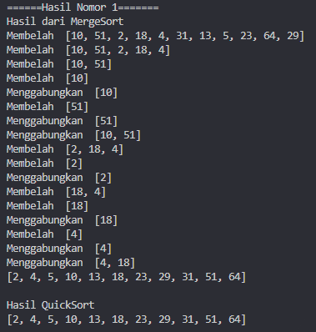

1. Memakai bolpen merah atau biru, tandai dan beri nomer urut eksekusi proses pada Gambar 6.1 dan 6.2, dengan mengacu pada output di halaman 59.

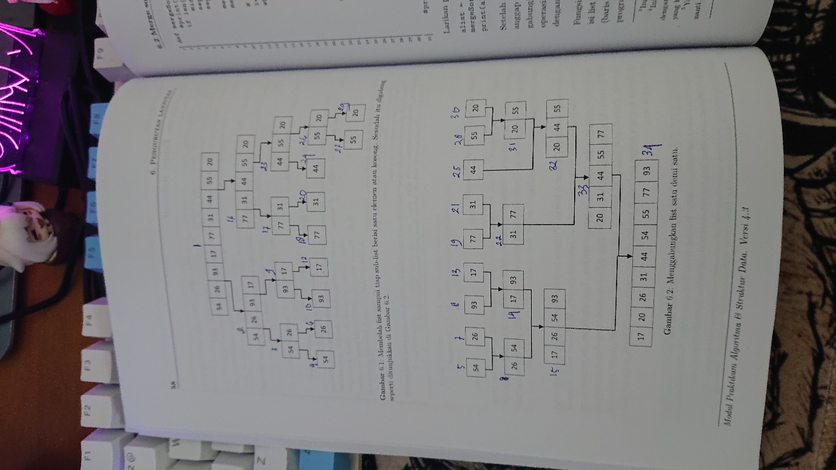

1. Uji kecepatan. Ujilah mergeSort dan quickSort di atas (bersama metode sort yang kamu pelajari sebelumnya) dengan kode di bawah ini.

Berikut kode program ;

from time import time as detak

from random import shuffle as kocok

import time

k = [i for i in range(1,6001)]

kocok(k)

def bubb(arr):

    n = len(arr)

    for i in range(n):

        for j in range(0, n-i-1):

            if arr[j] > arr[j+1] :

                arr[j], arr[j+1] = arr[j+1], arr[j]

def sele(A):

    for i in range(len(A)):

        min_idx = i

        for j in range(i+1, len(A)):

            if A[min_idx] > A[j]:

                min_idx = j

        A[i], A[min_idx] = A[min_idx], A[i]

def inse(arr):

    for i in range(1, len(arr)):

        key = arr[i]

        j = i-1

        while j >=0 and key < arr[j] :

                arr[j+1] = arr[j]

                j -= 1

        arr[j+1] = key

def mergeSort(arr):

    if len(arr) >1:

        mid = len(arr)//2

        L = arr[:mid]

        R = arr[mid:]

        mergeSort(L)

        mergeSort(R)

        i = j = k = 0

        while i < len(L) and j < len(R):

            if L[i] < R[j]:

                arr[k] = L[i]

                i+=1

            else:

                arr[k] = R[j]

                j+=1

            k+=1

        while i < len(L):

            arr[k] = L[i]

            i+=1

            k+=1

        while j < len(R):

            arr[k] = R[j]

            j+=1

            k+=1

def partition(arr,low,high):

    i = ( low-1 )

    pivot = arr[high]

    for j in range(low , high):

        if   arr[j] <= pivot:

            i = i+1

            arr[i],arr[j] = arr[j],arr[i]

    arr[i+1],arr[high] = arr[high],arr[i+1]

    return ( i+1 )

def quickSort(arr,low,high):

    if low < high:

        pi = partition(arr,low,high)

        quickSort(arr, low, pi-1)

        quickSort(arr, pi+1, high)

bub = k[:]

sel = k[:]

ins = k[:]

mer = k[:]

qui = k[:]

aw=detak();bubb(bub);ak=detak();print('bubble : %g detik' %(ak-aw))*;*

aw=detak();sele(sel);ak=detak();print('selection : %g detik' %(ak-aw))*;*

aw=detak();inse(ins);ak=detak();print('insertion : %g detik' %(ak-aw))*;*

aw=detak();mergeSort(mer);ak=detak();print('merge : %g detik' %(ak-aw))*;*

aw=detak();quickSort(qui,0,len(qui)-1);ak=detak();print('quick : %g detik' %(ak-aw))*;*

Berikut SS Ketika program dijalankan :

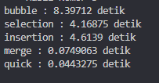

1. Diberikan list L = [80, 7, 24, 16, 43, 91, 35, 2, 19, 72], gambarlah trace pengurutan10 untuk algoritma.
2. Marge sort

|  |  |  |  |  |  |  |  |  |  |
| --- | --- | --- | --- | --- | --- | --- | --- | --- | --- |
| 80 | 7 | 24 | 16 | 43 | 91 | 35 | 2 | 19 | 72 |

Proses 1

|  |  |  |  |  |  |  |  |  |  |  |  |  |  |
| --- | --- | --- | --- | --- | --- | --- | --- | --- | --- | --- | --- | --- | --- |
| 7 | 80 |  | 26 | 24 |  | 43 | 91 |  | 2 | 35 |  | 19 | 72 |

Proses 2

|  |  |  |  |  |  |  |  |  |  |  |  |  |  |
| --- | --- | --- | --- | --- | --- | --- | --- | --- | --- | --- | --- | --- | --- |
| 7 | 16 | 24 | 80 |  |  |  |  |  |  |  | 72 |  |  |

|  |  |  |  |  |  |  |  |  |  |  |  |  |  |
| --- | --- | --- | --- | --- | --- | --- | --- | --- | --- | --- | --- | --- | --- |
|  |  |  |  |  | 2 | 35 | 43 | 91 |  |  | 19 |  |  |

Proses 3

|  |  |  |  |  |  |  |  |  |  |  |  |  |  |
| --- | --- | --- | --- | --- | --- | --- | --- | --- | --- | --- | --- | --- | --- |
| 2 | 7 | 16 | 24 | 35 | 43 | 80 | 91 |  |  | 72 | 19 |  |  |

Proses 4

|  |  |  |  |  |  |  |  |  |  |
| --- | --- | --- | --- | --- | --- | --- | --- | --- | --- |
| 2 | 7 | 16 | 19 | 24 | 35 | 43 | 72 | 80 | 91 |

1. Quick sort

|  |  |  |  |  |  |  |  |  |  |
| --- | --- | --- | --- | --- | --- | --- | --- | --- | --- |
| Pivot |  |  |  |  |  |  |  |  |  |
| 80 | 7 | 24 | 16 | 43 | 91 | 35 | 2 | 19 | 72 |
| Low |  |  |  |  |  |  |  |  | High |
|  |  |  |  |  |  |  |  |  | pivot |
| 72 | 7 | 24 | 16 | 43 | 91 | 35 | 2 | 19 | 80 |
| Low |  |  |  |  |  |  |  |  | high |
|  |  |  |  |  |  |  |  |  | Pivot |
| 72 | 7 | 24 | 16 | 43 | 91 | 35 | 2 | 19 | 80 |
|  |  |  |  |  | Low |  |  |  | High |
|  |  |  |  |  | Pivot |  |  |  |  |
| 72 | 7 | 24 | 16 | 43 | 80 | 35 | 2 | 19 | 91 |
|  |  |  |  |  | Low |  |  |  | High |
|  |  |  |  |  |  |  |  | Pivot |  |
| 72 | 7 | 24 | 16 | 43 | 19 | 35 | 2 | 80 | 91 |
|  |  |  |  |  | Low |  |  | High |  |
| Pivot |  |  |  |  |  |  |  |  |  |
| 72 | 7 | 24 | 16 | 43 | 19 | 35 | 2 | 80 | 91 |
| Low |  |  |  |  |  |  | High |  |  |
|  |  |  |  |  |  |  | Pivot |  |  |
| 2 | 7 | 24 | 16 | 43 | 19 | 35 | 72 | 80 | 91 |
| Low |  |  |  |  |  |  | High |  |  |
| Pivot |  |  |  |  |  |  |  |  |  |
| 2 | 7 | 24 | 16 | 43 | 19 | 35 | 72 | 80 | 91 |
| Low |  |  |  |  |  |  |  |  |  |
|  | Pivot |  |  |  |  |  |  |  |  |
| 2 | 7 | 24 | 16 | 43 | 19 | 35 | 72 | 80 | 91 |
|  | Low |  |  |  |  | High |  |  |  |
|  |  | Pivot |  |  |  |  |  |  |  |
| 2 | 7 | 24 | 16 | 43 | 19 | 35 | 72 | 80 | 91 |
|  |  | Low |  |  |  | High |  |  |  |
|  |  |  |  |  | Pivot |  |  |  |  |
| 2 | 7 | 19 | 16 | 43 | 24 | 35 | 72 | 80 | 91 |
|  |  | Low |  |  | High |  |  |  |  |
|  |  |  |  |  | Pivot |  |  |  |  |
| 2 | 7 | 19 | 16 | 43 | 24 | 35 | 72 | 80 | 91 |
|  |  |  |  | Low | High |  |  |  |  |
|  |  |  |  | Pivot |  |  |  |  |  |
| 2 | 7 | 19 | 16 | 24 | 43 | 35 | 72 | 80 | 91 |
|  |  |  |  | Low | High |  |  |  |  |
|  |  | Pivot |  |  |  |  |  |  |  |
| 2 | 7 | 19 | 16 | 24 | 43 | 35 | 72 | 80 | 91 |
|  |  | Low | High |  |  |  |  |  |  |
|  |  |  |  |  |  | Pivot |  |  |  |
| 2 | 7 | 16 | 19 | 24 | 35 | 43 | 72 | 80 | 91 |
|  |  |  |  |  | Low | High |  |  |  |
|  |  |  |  |  |  |  |  |  |  |
| 2 | 7 | 16 | 19 | 24 | 35 | 43 | 72 | 80 | 91 |

1. Tingkatkan efisiensi program mergeSort dengan tidak memakai operator slice (seperti A[:mid] dan A[mid:]), dan lalu mem-pass index awal dan index akhir bersama listnya saat kita memanggil mergeSort secara rekursif. Kamu akan perlu memisah fungsi mergeSort itu menjadi beberapa fungsi, mirip halnya dengan apa yang dilakukan algoritma quick sort.

Berikut kode program :

import random

def _merge_sort(indices, the_list):

    start = indices[0]

    end = indices[1]

    half_way = (end - start)//2 + start

    if start < half_way:

        _merge_sort((start, half_way), the_list)

    if half_way + 1 <= end and end - start != 1:

       _merge_sort((half_way + 1, end), the_list)

    sort_sub_list(the_list, indices[0], indices[1])

    return the_list

def sort_sub_list(the_list, start, end):

    orig_start = start

    initial_start_second_list = (end - start)//2 + start + 1

    list2_first_index = initial_start_second_list

    new_list = []

    while start < initial_start_second_list and list2_first_index <= end:

        first1 = the_list[start]

        first2 = the_list[list2_first_index]

        if first1 > first2:

            new_list.append(first2)

            list2_first_index += 1

        else:

            new_list.append(first1)

            start += 1

    while start < initial_start_second_list:

        new_list.append(the_list[start])

        start += 1

    while list2_first_index <= end:

        new_list.append(the_list[list2_first_index])

        list2_first_index += 1

    for i in new_list:

        the_list[orig_start] = i

        orig_start += 1

    return the_list

def merge_sort(the_list):

    return _merge_sort((0, len(the_list) - 1), the_list)

print(merge_sort([13,45,12,3,10,2]))

Berikut SS program ketikaa dijalankana :



1. Apakah kita bisa meningkatkan efisiensi program quickSort dengan memakai metode median-dari-tiga untuk memilih pivotnya? Ubahlah kodenya dan ujilah.

Berikut kode program :

print("\n"+"====Hasil Nomor 6=====")

def quickSort(L, ascending = True):

    quicksorthelp(L, 0, len(L), ascending)

def quicksorthelp(L, low, high, ascending = True):

    result = 0

    if low < high:

        pivot_location, result = Partition(L, low, high, ascending)

        result += quicksorthelp(L, low, pivot_location, ascending)

        result += quicksorthelp(L, pivot_location + 1, high, ascending)

    return result

def Partition(L, low, high, ascending = True):

    result = 0

    pivot, pidx = median_of_three(L, low, high)

    L[low], L[pidx] = L[pidx], L[low]

    i = low + 1

    for j in range(low+1, high, 1):

        result += 1

        if (ascending and L[j] < pivot) or (not ascending and L[j] > pivot):

            L[i], L[j] = L[j], L[i]

            i += 1

    L[low], L[i-1] = L[i-1], L[low]

    return i - 1, result

def median_of_three(L, low, high):

    mid = (low+high-1)//2

    a = L[low]

    b = L[mid]

    c = L[high-1]

    if a <= b <= c:

        return b, mid

    if c <= b <= a:

        return b, mid

    if a <= c <= b:

        return c, high-1

    if b <= c <= a:

        return c, high-1

    return a, low

liste1 = list([14,4,2,104,23,50])

quickSort(liste1, False)  *# descending order*

print('sorted:')

print(liste1)

Berikut SS program Ketika dijalankan :



1. Uji-kecepatan keduanya dan perbandingkan juga dengan kode awalnya.

Berikut kode programa :

from time import time as detak

from random import shuffle as kocok

import time

k = [i for i in range(1,6001)]

kocok(k)

def mergeSort(arr):

    if len(arr) >1:

        mid = len(arr)//2

        L = arr[:mid]

        R = arr[mid:]

        mergeSort(L)

        mergeSort(R)

        i = j = k = 0

        while i < len(L) and j < len(R):

            if L[i] < R[j]:

                arr[k] = L[i]

                i+=1

            else:

                arr[k] = R[j]

                j+=1

            k+=1

        while i < len(L):

            arr[k] = L[i]

            i+=1

            k+=1

        while j < len(R):

            arr[k] = R[j]

            j+=1

            k+=1

def partition(arr,low,high):

    i = ( low-1 )

    pivot = arr[high]

    for j in range(low , high):

        if   arr[j] <= pivot:

            i = i+1

            arr[i],arr[j] = arr[j],arr[i]

    arr[i+1],arr[high] = arr[high],arr[i+1]

    return ( i+1 )

def quickSort(arr,low,high):

    if low < high:

        pi = partition(arr,low,high)

        quickSort(arr, low, pi-1)

        quickSort(arr, pi+1, high)

import random

def _merge_sort(indices, the_list):

    start = indices[0]

    end = indices[1]

    half_way = (end - start)//2 + start

    if start < half_way:

        _merge_sort((start, half_way), the_list)

    if half_way + 1 <= end and end - start != 1:

       _merge_sort((half_way + 1, end), the_list)

    sort_sub_list(the_list, indices[0], indices[1])

def sort_sub_list(the_list, start, end):

    orig_start = start

    initial_start_second_list = (end - start)//2 + start + 1

    list2_first_index = initial_start_second_list

    new_list = []

    while start < initial_start_second_list and list2_first_index <= end:

        first1 = the_list[start]

        first2 = the_list[list2_first_index]

        if first1 > first2:

            new_list.append(first2)

            list2_first_index += 1

        else:

            new_list.append(first1)

            start += 1

    while start < initial_start_second_list:

        new_list.append(the_list[start])

        start += 1

    while list2_first_index <= end:

        new_list.append(the_list[list2_first_index])

        list2_first_index += 1

    for i in new_list:

        the_list[orig_start] = i

        orig_start += 1

def merge_sort(the_list):

    return _merge_sort((0, len(the_list) - 1), the_list)

def quickSortMOD(L, ascending = True):

    quicksorthelp(L, 0, len(L), ascending)

def quicksorthelp(L, low, high, ascending = True):

    result = 0

    if low < high:

        pivot_location, result = Partition(L, low, high, ascending)

        result += quicksorthelp(L, low, pivot_location, ascending)

        result += quicksorthelp(L, pivot_location + 1, high, ascending)

    return result

def Partition(L, low, high, ascending = True):

    result = 0

    pivot, pidx = median_of_three(L, low, high)

    L[low], L[pidx] = L[pidx], L[low]

    i = low + 1

    for j in range(low+1, high, 1):

        result += 1

        if (ascending and L[j] < pivot) or (not ascending and L[j] > pivot):

            L[i], L[j] = L[j], L[i]

            i += 1

    L[low], L[i-1] = L[i-1], L[low]

    return i - 1, result

def median_of_three(L, low, high):

    mid = (low+high-1)//2

    a = L[low]

    b = L[mid]

    c = L[high-1]

    if a <= b <= c:

        return b, mid

    if c <= b <= a:

        return b, mid

    if a <= c <= b:

        return c, high-1

    if b <= c <= a:

        return c, high-1

    return a, low

mer = k[:]

qui = k[:]

mer2 = k[:]

qui2 = k[:]

aw=detak();mergeSort(mer);ak=detak();print('merge : %g detik' %(ak-aw))*;*

aw=detak();quickSort(qui,0,len(qui)-1);ak=detak();print('quick : %g detik' %(ak-aw))*;*

aw=detak();merge_sort(mer2);print('merge mod : %g detik' %(ak-aw))*;*

aw=detak();quickSortMOD(qui2, False);print('quick mod : %g detik' %(ak-aw))*;*

Berikut SS program Ketika dijalankann :

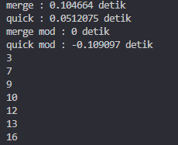

1. Buatlah versi linked-list untuk program mergeSort di atas.

Berikut kode program :

class Node:

  def __init__(self, data):

    self.**data** = data

    self.**next** = None

class LinkedList:

  def __init__(self):

    self.**head** = None

  def appendList(self, data):

    node = Node(data)

    if self.**head** == None:

      self.**head** = node

    else:

      curr = self.**head**

      while curr.**next** != None:

        curr = curr.**next**

    curr.**next** = node

  def appendSorted(self, data):

    node = Node(data)

    curr = self.**head**

    prev = None

    while curr is not None and curr.**data** < data:

      prev = curr

      curr = curr.**next**

    if prev == None:

      self.**head** = node

    else:

      prev.**next** = node

    node.**next** = curr

  def printList(self):

    curr = self.**head**

    while curr != None:

      print ("%d"%curr.**data**),

      curr = curr.**next**

  def mergeSorted(self, list1, list2):

    if list1 is None:

      return list2

    if list2 is None:

      return list1

    if list1.data < list2.data:

      temp = list1

      temp.next = self.mergeSorted(list1.next, list2)

    else:

      temp = list2

      temp.next = self.mergeSorted(list1, list2.next)

    return temp

list1 = LinkedList()

list1.appendSorted(13)

list1.appendSorted(12)

list1.appendSorted(3)

list1.appendSorted(16)

list1.appendSorted(7)

print("List 1 :"),

list1.printList()

list2 = LinkedList()

list2.appendSorted(9)

list2.appendSorted(10)

list2.appendSorted(1)

print("List 2 :"),

list2.printList()

list3 = LinkedList()

list3.**head** = list3.mergeSorted(list1.**head**, list2.**head**)

print("Merged List :"),

list3.printList()

Berikut SS Ketika program dijalankan :

